RECYCLE FLORIDA TODAY 2010 ANNUAL CONFERENCE
Solid Waste Management Department
AFTER ACTION REPORT (June 13 – 15, 2010)

INTEGRATED SOLID WASTE MANAGEMENT STRATEGY: As part of the ISWMS, the Board of County Commissioners directed staff to boost residential, commercial and special events recycling as key objectives. Waste Reduction & Recycling staff are responsible to preserve valuable landfill airspace by developing and implementing “innovative” programs to reduce, re-use, and recycle solid waste while protecting natural resources at best value and to provide education & outreach on recycling to single family, multi-family, and businesses.

BACKGROUND: Staff attended the 2009 Recycle Florida Today (RFT) conference at Port Cape Canaveral, Florida. The RFT Annual Conference and Exhibition provided a premier forum for informing the public and private sectors of the economic and environmental significance of recycling and waste reduction. Staff had excellent networking opportunities and a chance to visit the exhibits to preview the “newest advances” in recycled products and services. Staff obtained continuing education credits for SWANA certification requirements and innovative and creative opportunities to sustain and increase our level of recycling performance.

EXHIBIT/PRESENTATION: The FDEP Grant IG8-09 requires us to disseminate “Lessons Learned” from managing the Business “How to Recycle” video grant. The FDEP approved funding an exhibit table and subsidized staff attendance at the conference. Staff manned a display table presenting the “How to Recycle” business video lessons learned. There were approximately eighty attendees at the RFT conference. Forty-five people who visited the SWMD exhibit booth requested handout informational material and copies of the “How to Recycle” business DVD’s.
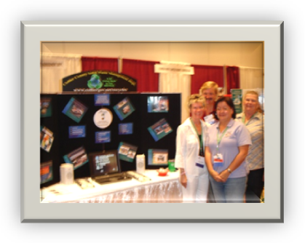. 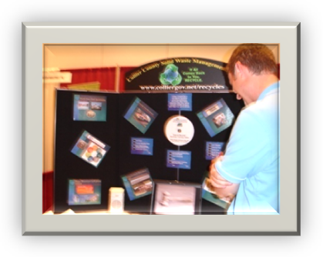
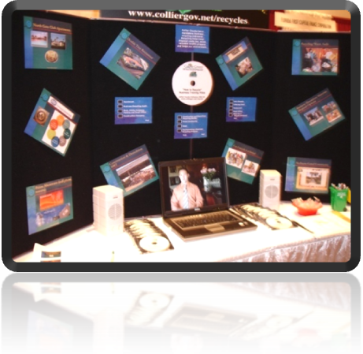

LESSONS LEARNED:
- Florida Solar Energy Center Tour: Staff participated in a very informative tour of the Florida Solar Energy Center. The center has an excellent educational program on solar power and it uses to conserve energy. In addition the center tests various types of solar panels to certify the panels for warranty. SWMD is interested in solar power technology for potential use at the Naples and Immokalee Landfills. The portable solar generator and photovoltaic disaster response trailer could be used during hurricanes to provide power at a scale house.
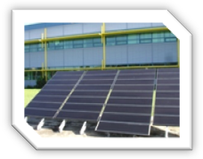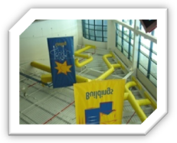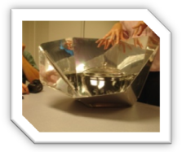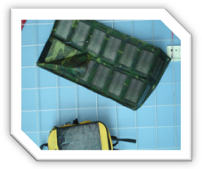 Solar Panels Windows Inside Solar Cooking Bag Pack for Computer
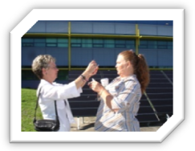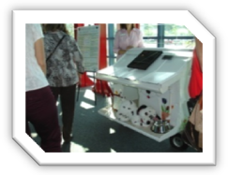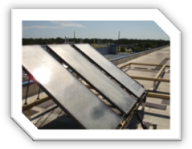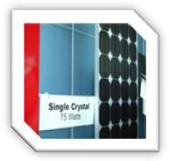 Experimenting w/Solar Dog House w/ Solar Roof Solar Roofing Single Crystal Solar
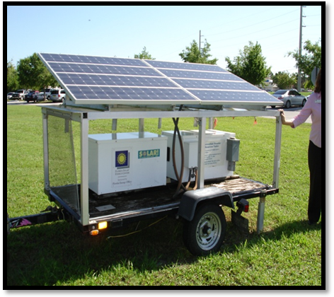 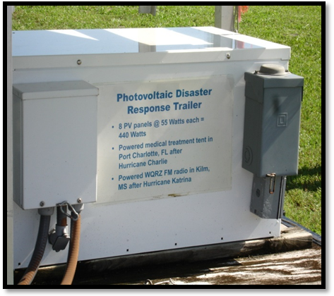 Portable Solar Generator Solar – Disaster Response Trailer
- South Dade Soil and Water Conservation District: (http://southdadeswcd.org/ ) Staff was able to share lunch and conversation with Mr. William Townshend, Director of Composting Operations who received an award at RFT. Mr. Townshend has agreed to travel to Collier County to make a presentation to our division and/or department on the in-vessel aerobic composting of food waste, yard waste, sludge, cow and hog manures, poultry litter, and animal waste/carcasses. Lanette Sobel of Ecotel based in Miami, and Ft. Lauderdale lanette@ecotelconsulting.com is doing the marketing to recruit hospitality companies to participate.
- Recycling Market Development: Mitch Kessler, of Kessler Consulting, Inc. performed research for the City of Tallahassee funded by an FDEP Innovation grant to benchmark national recycling best practices. Staff has requested a copy of his RFT PowerPoint and supporting documents. This research is being done as part of a report to the Legislature on the possibility of the new 75% recycling goals for the state. These best practices may assist us with implementing the current Integrated Solid Waste Management Strategy and shape the next five year strategy.
- Recycling of Milk/juice Cartons: Staff learned that gable top and milk/juice cartons can be recycled and some MRF facilities are accepting these materials. Staff would like to recommend including juice/milk cartons, beverage/food cartons and gable top items into the franchise collection and recycling agreement. The Carton Council is willing to form a partnership in advertising this change.
- Overview of Carbon Credits and How They Work: Staff was able to learn more about carbon credits and carbon foot prints, account for net sources of “greenhouse” gases, and how it is generated from Landfills, Wastewater Treatment Plants, and Biosolids.
- EPA Recycling Tool Kit: Mary Beth VanPelt from EPA was a presenter at the conference and staff learned that they have updated their toolkit for recycling. They have the EPA Region 4’s Municipal Government Toolkit for Recycling that focuses on the impact of recycling on the economy, climate change and any community.
- School Recycling in Pasco County: Karen Bryant, Recycling Coordinator and Resource Recovery for Pasco Schools shared monthly school recycling documents to be shared with Collier County Schools. The Pasco County School Board self hauls school supplies and back hauls recycling materials from their schools. They also reduced the size of mixed waste dumpsters at schools to force Principals into recycling.
- Public Outreach and Advertising: Lena Davie, President of Hill and Knowlton, Inc. provided an excellent presentation on “Smart Media in Cost Cutting Times”. Her firm recently put together an advertising campaign for the State of Georgia to increase their recycling rates state wide. Staff was able to speak with Ms. Davie at length and brought back some new ideas for public outreach.
- NEW Recycle Equipment: Latest and newest equipment to recycle plastic, bottles & aluminum cans.

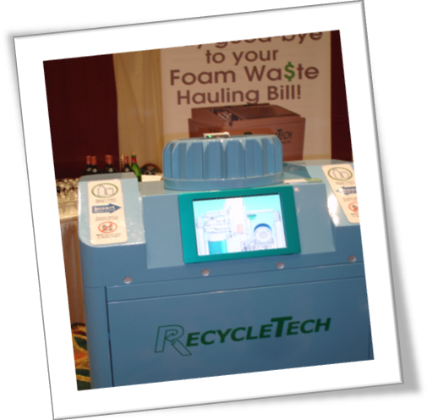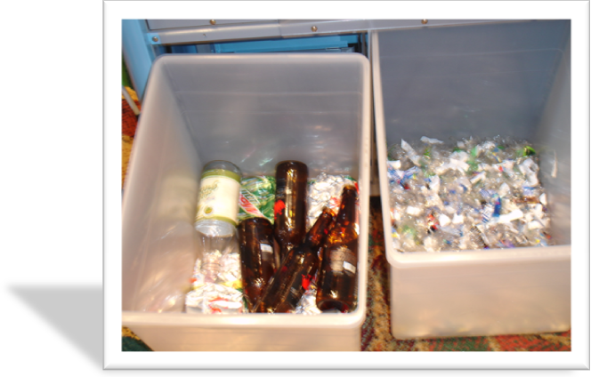

SUMMARY: Attendance at the 2009 RFT was a great opportunity to increase single family, multi-family and business recycling in Collier County as part of the Tactical Action Plan and Integrated Solid Waste Management Strategy. This conference provided the avenue to network with other communities in Florida for innovative and creative processes to comply with the FDEP’s 75% recycling rate by 2020 (Florida State Chapter 403.7032).

